**ABRAHAM MERCY**

* 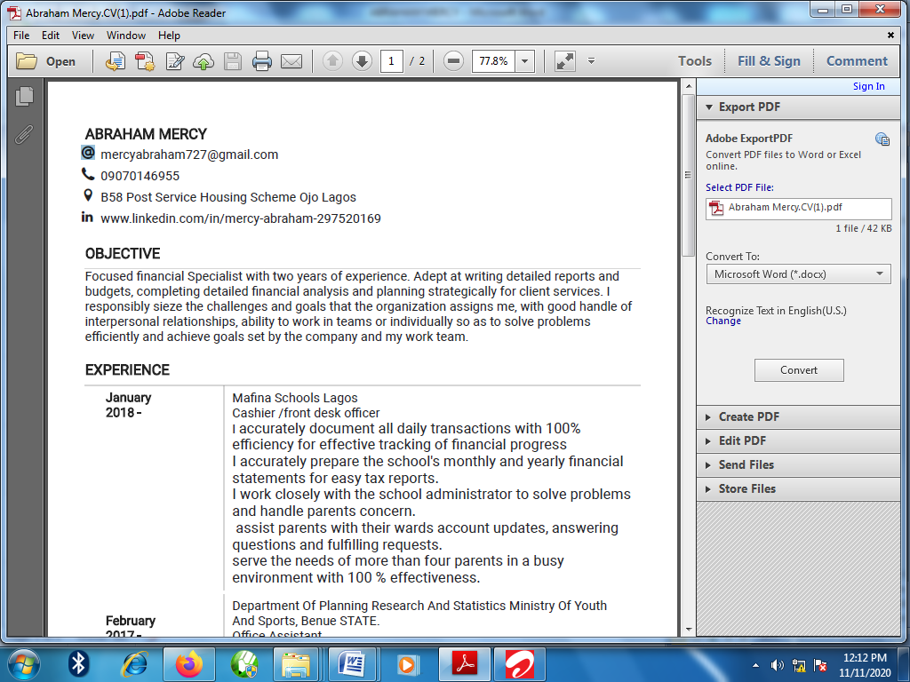mercyabraham727@gmail.com

*

 09070146955

 L 9 Awesu street Eputu-London Ibeju Lekki Lagos

www.linkedin.com/in/mercy-abraham-297520169

**OBJECTIVE**

Focused customer service representative with strong understanding of retail operations with over two years of experience. Adept at writing detailed reports and budgets, completing detailed financial analysis and planning strategically for client services. I responsibly seize the challenges and goals that the organization assigns me, with good handle of interpersonal relationships, ability to work in teams or individually so as to solve problems efficiently and achieve goals set by the company and my work team.

**EXPERIENCE**

**January 2018** **Mafina Schools Lagos**

**Cashier /Front Desk Officer**

I accurately document all daily transactions with 100% efficiency for effective tracking of financial progress

I accurately prepare the school's monthly and yearly financial statements for easy tax reports.

I work closely with the school administrator to solve problems and handle parents concern.

Assist parents with their wards account updates, answering questions and fulfilling requests.

Serve the needs of more than four parents in a busy environment with 100 % effectiveness.

**February 2017 to** **Department Of Planning Research And Statistics Ministry**

**December 2017**  **of Youth and Sports, Benue State.**

**Office Assistant**

As a National service Corp,I Conducted field visits with the director and met corporate customers for business development

Documented meeting minutes and distributed to staff to facilitate follow-up and permanent record

Operated with high integrity, built trust, and earned sustained credibility with internal and external clientele

Ordered office supplies and researched supplier discounts.

**EDUCATION**

**2015**  Abia state University Uturu

BSc Statistics

**SKILLS**

* Documentation and reporting
* Proficient in the use of MS Word
* Interpersonal skills
* Database administration skill
* Written and Oral Communication

**PERSONAL DETAILS**

Date of Birth: 13th April 1995

Marital Status: Single